**Suggested improvements::**

1)Silly yet gross mistake:Spelling of “leave” needs to be rectified in the following example:: 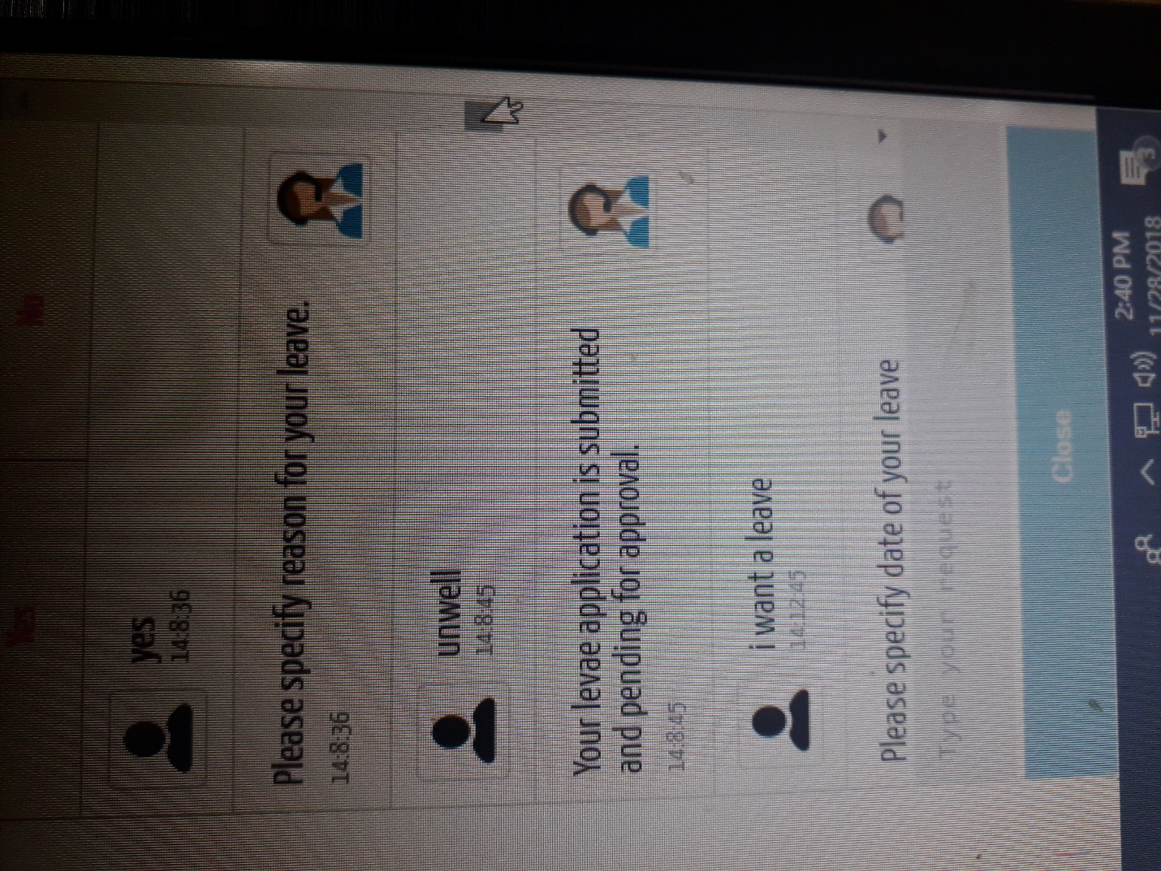

2)Only 2 types of leaves have been included(sick and casual).I think the **maternity** leave should be included and anything more if appropriate from the list::

a)transfer leave

b)casual leave

Currently,*maternity leave is taken into a casual leave* as shown:

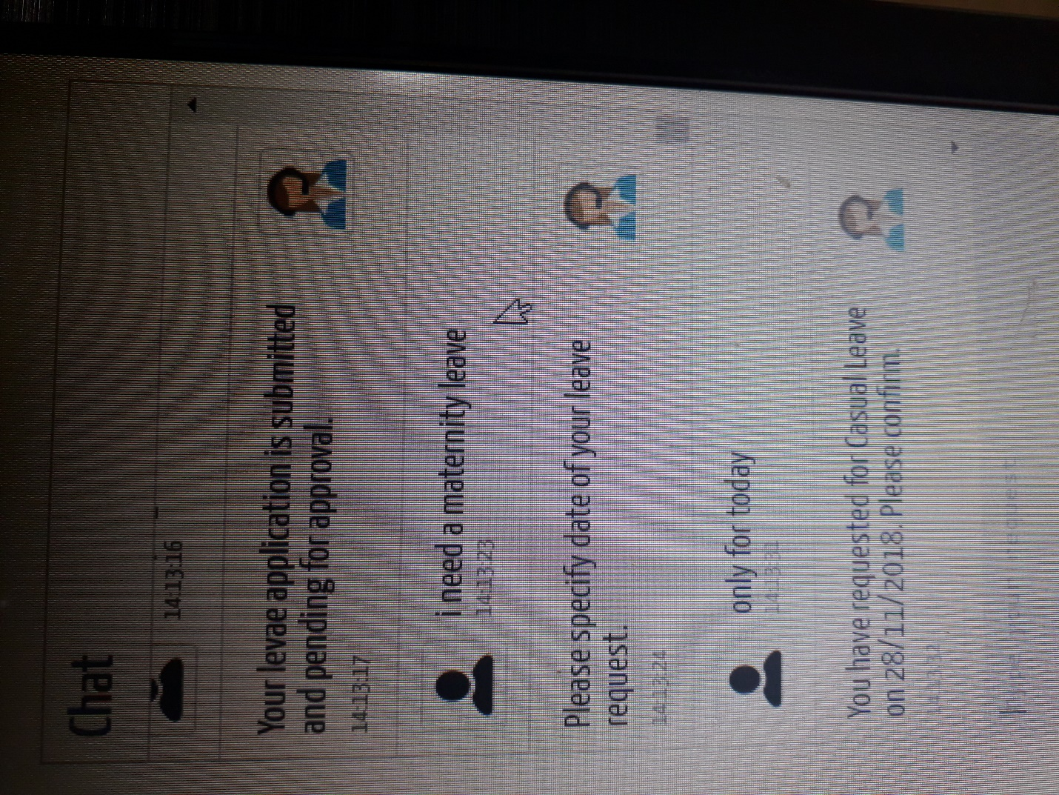

which should not be the case.**A maternity leave is much more serious than a casual leave.**

Hence this should be rectified.

3)If the user says “I want a leave”,we should ask him “Specify type of leave” just as we ask later “Give reason” else there can be **possible mismatch of thoughts.**

For example:The user says “I want a leave” and in the reason gives “I am sick/I have fever/I am unwell” the system takes it to be a casual leave which is not true.

Hence if type of leave is not given we can prompt the user for the type to avoid such errors. 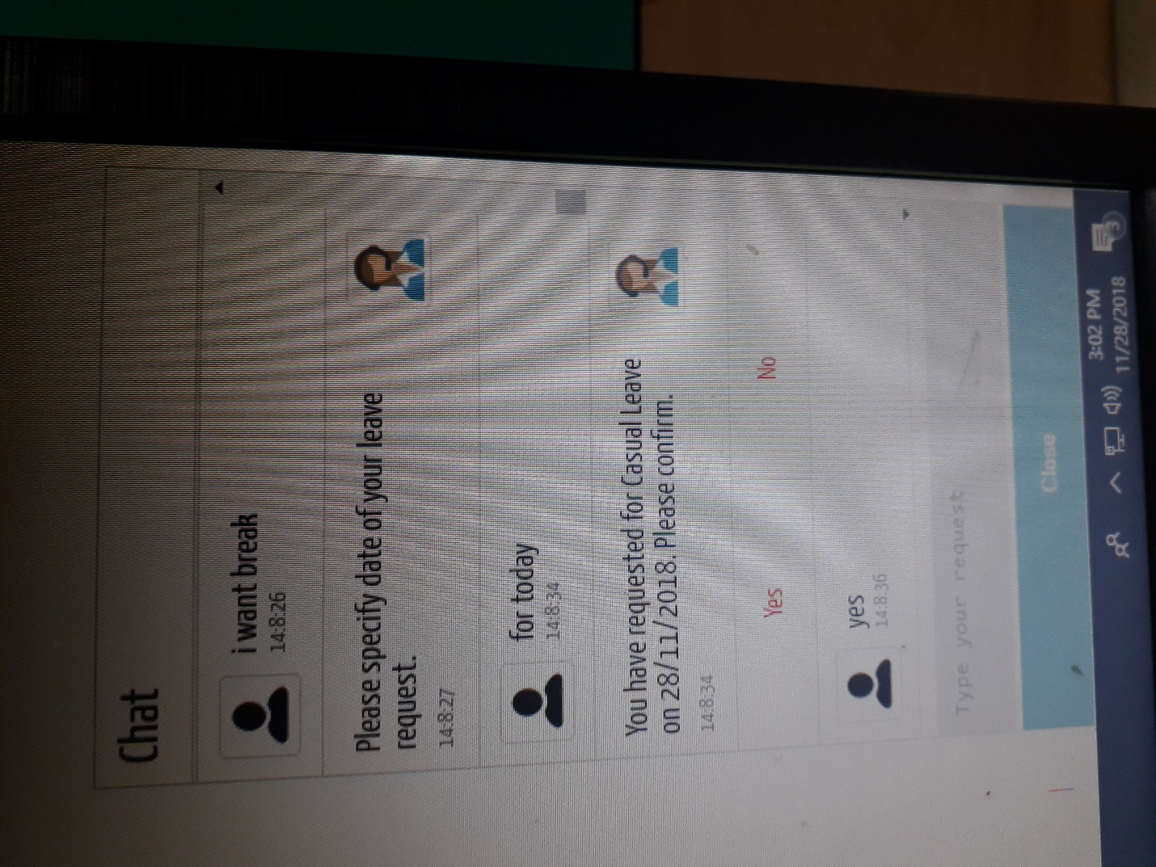

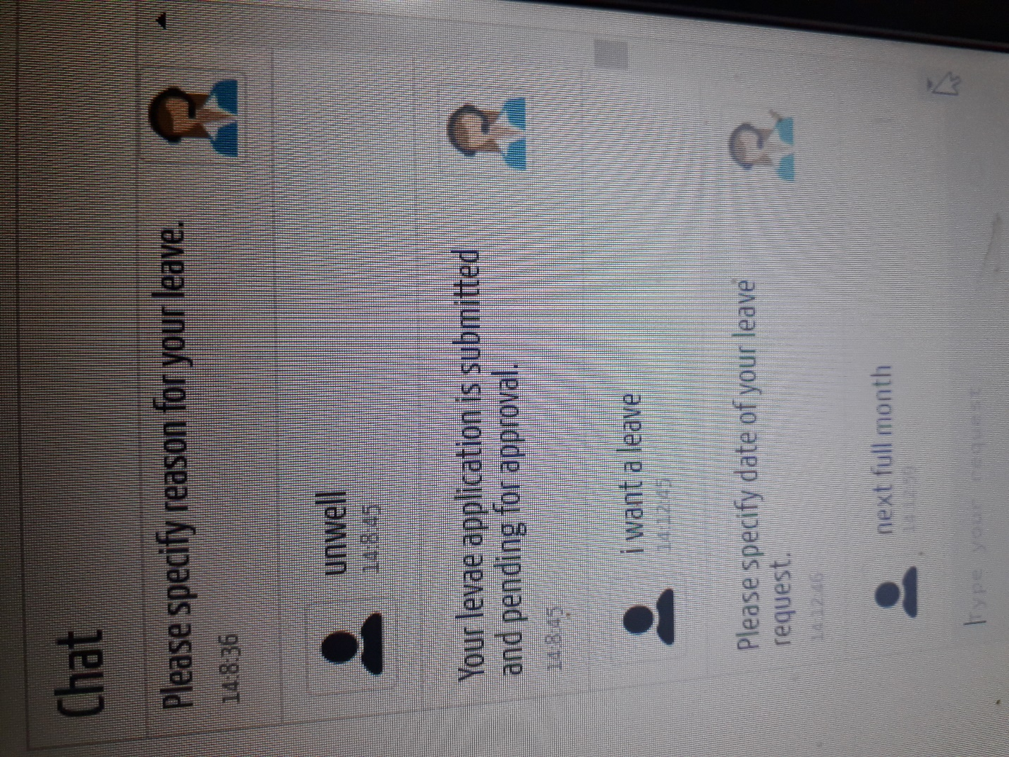

**Minor suggestions:**

Some errors I found:

1)I typed in this way to change type of leave and the bot could not handle it.

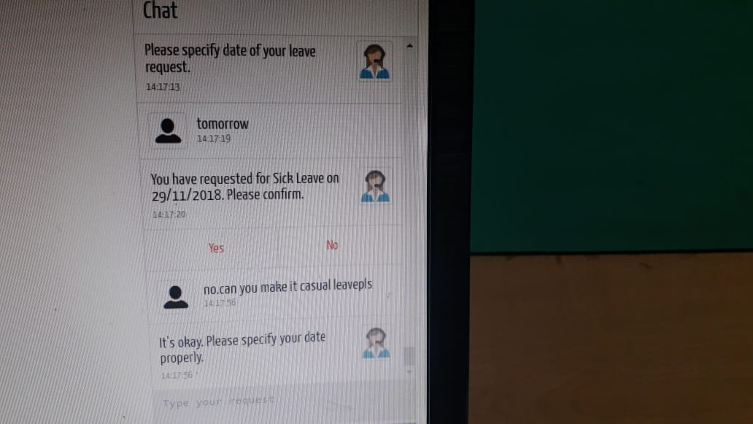

2)For example to end the chat “if I say thank you”;bot interprets it as something else(the user may commonly use thank you to finish .

